23CSE202 DATABASE MANAGEMENT SYSTEMS
S3 B.Tech CSE
Department of Computer Science and Engineering
Amrita School of Computing, Amritapuri Campus
3. Database Design Document
Group No : D9
Team Members :
Roll No | Student Name
AM.SC.U4CSE25359 | Abel Binu Varghese
AM.SC.U4CSE25360 | Alien Lakshmi C
AM.SC.U4CSE25366 | Kasinath V
AM.SC.U4CSE25368 | Devananda J A

Project Title : Contact Management System

3.1. Detailed description of the project
The Contact Management System (CMS) is designed for individuals and small teams who need a single, reliable place to store and organise the contacts they interact with — friends, family, colleagues and clients — instead of scattering this information across phone address books, email accounts and paper records. The system is backed by a relational database (implemented in MySQL/PostgreSQL) that models contacts, the groups/categories they belong to, the communication history associated with each contact, and the users who are permitted to access and modify this data.
Three types of users interact with the system. An Administrator has full access: they can add, edit and delete any contact, manage user accounts (creating new Editor or Viewer accounts and assigning roles), and inspect the activity log that records every login, logout, and contact/user change together with a timestamp. An Editor can add, edit, delete and search contacts but cannot manage other users. A Viewer can only search and view existing contacts. Every contact record stores the contact's name, phone number, email address, postal address, birthday and company. Contacts are categorised (Personal, Business, Family, Academic, or any custom label an Administrator defines) purely through their membership in groups rather than through a fixed field on the contact itself, since the same contact may reasonably belong to more than one group (for example, a person who is both a colleague and a personal friend) — this is why groups and contacts share a many-to-many relationship, realised through a bridging table, instead of a single category column that could only ever hold one value. Each contact can also accumulate multiple communication log entries — calls, messages or meetings — recorded against it over time; because a communication log entry has no independent existence outside the contact it belongs to, it is modelled as a weak entity. Each communication log entry additionally records which user logged it, and every user account records the date it was created, so that accountability and auditing are supported at both the account level and the individual-record level.
Several business rules govern the system: the database must detect and prevent duplicate contact entries (matching on phone number or email) before a new record is inserted, using a trigger; a stored procedure must be able to safely merge two duplicate contact records without losing any of the communication history already logged against either of them; and every contact must be traceable to the user who added it, while every login, logout and data modification must be written to the activity log for accountability. Views are used to summarise information such as the most frequently contacted individuals and the group-wise distribution of contacts, and indexes are maintained on the name and phone columns of the Contacts table so that search, filter and sort operations stay fast as the volume of data grows.

3.2. ER Diagram
The entity-relationship diagram below models five entities — USERS, CONTACTS, GROUPS, ACTIVITY_LOG and COMMUNICATION_LOG (a weak entity, shown with a double-bordered box) — connected through five relationships: ADDS (1:M, a user adds many contacts), BELONGS_TO (M:N, a contact can belong to many groups and a group can contain many contacts), HAS (1:M identifying relationship with total participation, since a communication log entry cannot exist without the contact it is logged against), PERFORMS (1:M, a user performs many logged activities) and LOGGED_BY (1:M, a user logs many communication log entries, giving each entry a traceable author in addition to the contact it belongs to). Each entity box lists its attributes with PK (primary key) and FK (foreign key) markers; the partial key of the weak entity COMMUNICATION_LOG (log_id) is marked accordingly within its double-bordered box.
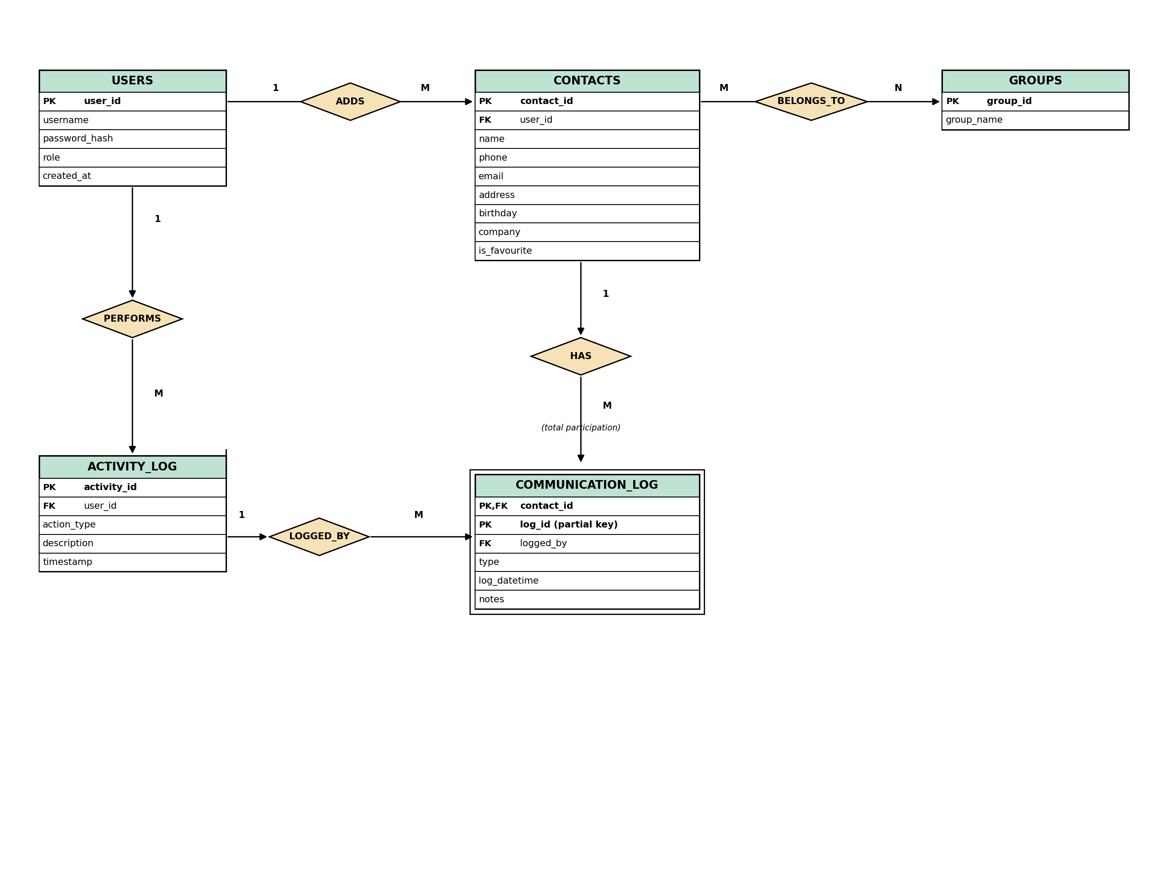
Fig 3.1: ER Diagram for the Contact Management System

3.3 Relational Schema
Applying the standard entity-to-table and relationship-to-table mapping rules to the ER diagram in Fig 3.1 produces six relations. Primary-key attributes are shown in bold and underlined; the notes beneath each relation state the primary key and any foreign keys.
USERS (user_id, username, password_hash, role, created_at)
Primary Key: user_id.
CONTACTS (contact_id, name, phone, email, address, birthday, company, is_favourite, user_id)
Primary Key: contact_id. Foreign Key: user_id → USERS(user_id) — the user who added the contact.
GROUPS (group_id, group_name)
Primary Key: group_id.
CONTACT_GROUP (contact_id, group_id)
Primary Key: (contact_id, group_id) — composite, since the relationship BELONGS_TO is many-to-many. Foreign Keys: contact_id → CONTACTS(contact_id), group_id → GROUPS(group_id).
COMMUNICATION_LOG (contact_id, log_id, type, log_datetime, notes, logged_by)
Primary Key: (contact_id, log_id) — composite, because log_id is only the partial (discriminator) key of the weak entity and is unique only within a given contact. Foreign Keys: contact_id → CONTACTS(contact_id), logged_by → USERS(user_id) — the user who recorded the entry.
ACTIVITY_LOG (activity_id, user_id, action_type, description, timestamp)
Primary Key: activity_id. Foreign Key: user_id → USERS(user_id) — the user who performed the logged action.

3.4 Normalization and Functional Dependency Analysis

(a) Functional Dependencies Identified
Relation | Functional Dependency (Determinant → Dependent Attributes)
USERS | user_id → username, password_hash, role, created_at
CONTACTS | contact_id → name, phone, email, address, birthday, company, is_favourite, user_id
GROUPS | group_id → group_name
CONTACT_GROUP | No non-key attribute — exists purely to record that a contact belongs to a group
COMMUNICATION_LOG | (contact_id, log_id) → type, log_datetime, notes, logged_by
ACTIVITY_LOG | activity_id → user_id, action_type, description, timestamp

(b) Candidate Keys, Justified with Attribute Closure
Relation | Attribute Closure | Candidate Key
USERS | {user_id}⁺ = all attributes of USERS | user_id
CONTACTS | {contact_id}⁺ = all attributes of CONTACTS | contact_id
GROUPS | {group_id}⁺ = all attributes of GROUPS | group_id
ACTIVITY_LOG | {activity_id}⁺ = all attributes of ACTIVITY_LOG | activity_id
CONTACT_GROUP | {contact_id}⁺ = {contact_id} only; {group_id}⁺ = {group_id} only; {contact_id, group_id}⁺ = full attribute set | (contact_id, group_id) — composite
COMMUNICATION_LOG | {log_id}⁺ = {log_id} only (repeats across contacts); {contact_id, log_id}⁺ = full attribute set | (contact_id, log_id) — composite

(c) Normalization Process (1NF → 2NF → 3NF/BCNF)
Relation | 1NF | 2NF | 3NF / BCNF
USERS | Satisfied — all attributes atomic, single-valued | Satisfied trivially — single-attribute key, no partial dependency possible | Satisfied — determinant of every FD is a candidate key
CONTACTS | Satisfied — all attributes atomic, single-valued | Satisfied trivially — single-attribute key, no partial dependency possible | Satisfied — no non-key attribute determines another non-key attribute
GROUPS | Satisfied — all attributes atomic, single-valued | Satisfied trivially — single-attribute key, no partial dependency possible | Satisfied — determinant of every FD is a candidate key
CONTACT_GROUP | Satisfied — repeating group of group memberships extracted into this bridge relation | Satisfied trivially — no non-key attribute exists to be partially dependent | Satisfied — no non-key attributes, so no transitive dependency possible
COMMUNICATION_LOG | Satisfied — repeating group of log entries extracted into its own relation | Satisfied — type, log_datetime and notes each depend on the whole composite key (contact_id, log_id) together, not on either part alone | Satisfied — determinant (contact_id, log_id) is the candidate key; no transitive dependency
ACTIVITY_LOG | Satisfied — all attributes atomic, single-valued | Satisfied trivially — single-attribute key, no partial dependency possible | Satisfied — determinant of every FD is a candidate key

(d) Resulting Benefit
Because every relation is already in BCNF, the schema is free of the insertion, update and deletion anomalies that a single denormalized “contact sheet” table would suffer from: deleting a contact's only logged call no longer risks losing that contact's address or company details, updating a group's name only requires touching one row of GROUPS, and recording a brand-new group no longer requires touching the CONTACTS table at all.

